RULES, POLICIES, AND REGULATIONS GOVERNING THE HOPE EVANGELICAL LUTHERAN CHURCH COLUMBARIUM

PURPOSE
The Columbarium of Hope Evangelical Lutheran Church (the “Columbarium” and the “Church”) has been created to provide for the spiritual well-being of the Church members at times of death and bereavement and to establish a final consecrated resting place for evidence of Christian witnesses, a symbolic statement of the unity of Christian community and a peaceful gathering place for families and friends. The Columbarium will provide a space for depositing a crematory urn (“inurnment”) of cremated human remains (“cremains”) of deceased Church members and other eligible persons, as determined by the Pastor(s) and the Columbarium Board.

GOVERNANCE
The administration, operation and maintenance of the Columbarium is the ultimate responsibility of the Church Board which may delegate its authority, as appropriate, to the Columbarium Board. The Columbarium Board shall be responsible for making ongoing decisions regarding the Columbarium and assure that the Rules, Policies, and Regulations are followed. The Columbarium Board shall be appointed by the Church Board and shall consist of 3 congregational members (the Financial Secretary, the Property Director, and a member of the congregation who is not on the Church Board) and a pastor(s). The member of the congregation who is not on the Church Board shall serve a three-year term on the board which is renewable by the Church Board.
The Columbarium Board shall meet as necessary. The Columbarium Board shall report to the Church Board and to the congregation at least once per year including the results of the annual audit discussed below.
The Columbarium Board will appoint an Administrator who will have the direct responsibility for keeping records, handling sales, and coordinating inurnment. This may be the Finance Office Manager or a volunteer. The Pastor(s)will be involved in the appointment process. The Columbarium Board shall perform an annual audit of the records, sales and other functions performed by the Administrator. The results of the audit shall be included in the Columbarium annual report which will be included in the Annual Reports submitted in the 1st quarter to the congregation.

ELIGIBILITY FOR INURNMENT
Inurnment in the Columbarium shall be limited to the cremated human remains of any member or former member of the Church, and members of his or her immediate family. Members of his or her immediate family shall include the following:
  - Spouse of the member or former member.
  - Parents, stepparents, grandparents or step-grandparents of the member or former member.
  - Children or stepchildren of the member or former member.
  - Spouses of children or stepchildren of any member or former member.
  - Grandchildren or step-grandchildren of any member or former member.
Any minister or former minister of the Church and his or her spouse and members of his or her immediate family (as defined above) are also eligible. Other exceptions for eligibility for inurnment may be made by discretion of the church Pastor(s).

FEES – COLUMBARIUM NICHE(S)
The current one-time fee for the right of inurnment in the Columbarium is the following ‘Tier’ pricing:
Tier | Double | Single*
1st Level | $2,600.00 | $1,300.00
2nd Level | $2,800.00 | $1,400.00
3rd Level | $3,000.00 | $1,500.00
4th Level (TOP) | $3,400.00 | $1,700.00
*Pricing reflects single cremains with the understanding that an additional set of cremains may be inurned in the same niche. Purchaser has the option to reserve a single niche (one set of cremains) at Double pricing.
This fee includes all costs directly associated with inurnment, inscription of two names and associated dates (birth year and death year) on the niche shutter. The fee does not include the cost of cremation, the urn, transportation or other off -premises costs. The fee may be changed in the future by the Church Board. Holders of Certificates (as hereinafter defined) will neither be reimbursed nor assessed additional costs if the fee changes.
The purchase price of the niche shall be payable upon execution of this document or equally in annual installments with a non-refundable reservation payment of $500.00 at time of execution, with the balance to be paid annually in equal payments over a 12-, 24- or 36-month period by the anniversary date of this document. If any installment payment is past due and the default is not cured within sixty (60) days of written notice to the Purchaser’s last known address, the reservation shall expire and all previous payments shall be refunded, except for the initial reservation payment of $500.00. No inurnment shall be made until the Purchaser has paid in full.
One or two urns may be inurned in each niche. To fit in the space envelope of the niche (approximately 12.50” long x 12.50” high x 15” deep), the dimension of each urn (provided by the family of the deceased) shall be:
- If one urn will be inurned, the urn shall fit a space envelope of less than 12 inches tall by 12 inches wide by 12 inches deep (or diameter)
- If two urns will be inurned, each urn shall fit a space envelope of less than 12 inches tall by 12 inches wide by 7 inches deep (or diameter)
The Church Board reserves the right to charge an additional fee for inscription of the additional name and dates on the niche shutter and opening/closing of the niche. This fee may be changed in the future by the Church Board to account for changes in inscription costs. After an application has been filed and approved by the Columbarium Board, and final payment is received, a Certificate will be provided by the Administrator.
To purchase a niche, an eligible person should obtain the “Application for Certificate of Right of Inurnment” form from the church office. The applicant should complete the form and submit it to the Columbarium Board (through the Administrator).
When the application is approved, payment for the niche shall be provided by the applicant. Once full payment has been received, the applicant (now “Certificate Holder”) will be issued a Certificate for a given niche in the Columbarium.

TITLE AND RETAINED RIGHTS
The Certificate Holder acquires no property rights in the Columbarium, any of its niches or any of the Church’s property. Legal title to the Columbarium and all niches remains with the Church at all times. The Certificate attests only to the right to inurn the cremains of the person(s) named on the Certificate in the specific niche listed in the Certificate. Assignment of cremains to a specific niche shall constitute only a license to use such niche pursuant to these Rules, Policies and Regulations, as amended from time to time. In the event of a discrepancy between the Certificate and the administrative records maintained by the Columbarium Board, the latter shall take preference.

SELECTION OF NICHES
After an application has been approved and initial reservation payment of $500 is received, the Certificate Holder will have the right to select any niche(s) purchased on their Tier Level which may be available at that time. If more than one application shall have been approved on the same date, the rights of preference shall be based on the date and time the completed applications are received. No more niches will be sold to a family than those necessary to inurn the cremains of all eligible persons in that family, with two urns to a niche. One urn/person. One granite shutter per niche. Those niches which contain two urns will have one granite shutter with two sets of inscriptions. Inscriptions on the granite shutters will all use the same font and size for the Name and Dates as determined by the Columbarium Board.

INURNMENT PROCEDURES
  - Services: Only an installed pastor serving the Church, or an ordained minister invited by an installed pastor of the Church, shall be authorized to officiate at an inurnment service at the Columbarium. If the Church does not have a currently installed pastor, an ordained pastor of the ELCA may officiate as approved by the Church Board and the SWPA Synod. The committal service shall be at the convenience of the minister, the Church, and the family of the deceased to be inurned. A family representative is responsible for making inurnment arrangements with the Church. A trained member of the church (or designated contractor) will remove the granite shutter and open/close the niche. A pastor or witness from the church will observe the opening/closing of the niche.
  - Urns: Each Niche in the Columbarium shall have the capacity to hold two urns. The urn(s) that will be used for inurning cremains in the Columbarium must be smaller than the space envelope prescribed in Section D above. These may be obtained from a funeral home or other memorial suppliers. The name of the deceased shall be permanently affixed to the urn.
  - Certification: Documentation from the Funeral Director or Crematorium is required to certify the identity of the cremains to be placed in the Columbarium.

  - Inscription on Niche Shutters:
    - Uniformity of Inscription: the inscription shall be in a uniform size and style as determined by the Columbarium Board. The purchase price of the niche in the Columbarium shall include the cost of one such inscription on the shutter. The cost of subsequent inurnments in the same niche will include the cost of the additional inscription (on the original shutter) which will be the same size and style as the original inscription.
*Note: Any single purchaser of a double niche has the opportunity for additional lines of text.

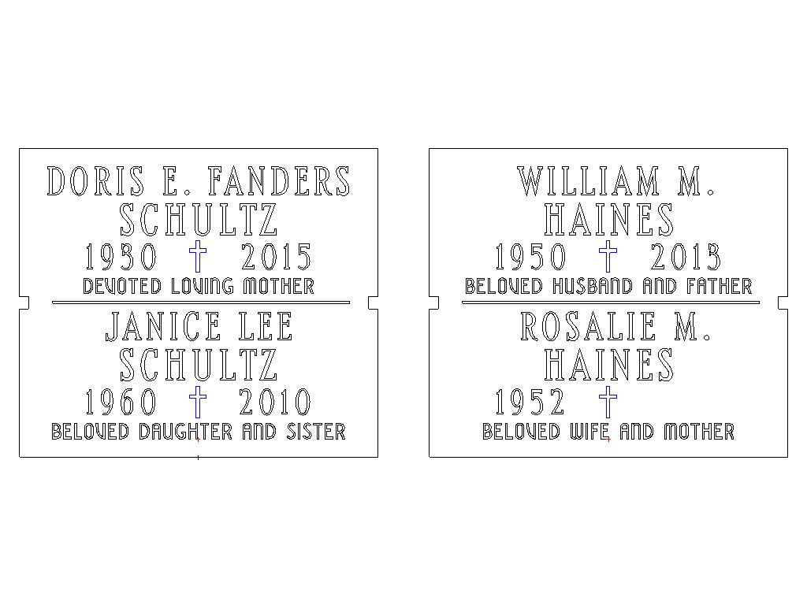
    - Conformity of Text: the inscription shall consist of the following:

    - Correctness of Inscription: An inscription order form will be provided by the Columbarium Board to be typed or printed in ink and signed by the person or persons entitled to do so (Purchaser or next of Kin). Arrangements for the inscription, in accordance with the name and dates so furnished, will be made by the Columbarium Board. The Church and the Columbarium Board shall be responsible only for such errors in the inscription as might be made by the party doing the inscription which deviates from the name and dates as completed on the signed inscription order.
    - Any cost to correct an inscription error due to an incorrectly completed inscription form shall be borne by the Purchaser.
    - Purchaser(s) must use only the approved Church vendors. No outside vendors may be used for any work involving the Columbarium.
    - Hope Lutheran reserves the right to approve the inscription message to ensure conformity with the church’s mission and values.

TRANSFER OR REASSIGNMENT OF RIGHTS
  - Right of First Refusal: The Columbarium Board retains the right of first refusal to purchase the unused inurnment rights from any Certificate Holder of such rights at the then current standard purchase price or the original purchase price, whichever is the lower, prior to the transfer or reassignment of said rights to any new Certificate Holder. Any new Certificate Holder must meet the criteria in Section C of this document, Eligibility for Inurnment, and would be subject to approval by the Columbarium Board.
  - Niche Use: No cremains may be inurned in any niche except those for the persons listed on the Certificate for that niche.

SECURITY OF CREMAINS
The Church will use reasonable care to protect all urns deposited in the Columbarium. The Church disclaims all responsibility and shall be relieved from any liability for loss or damage from causes beyond its reasonable control, including, without limitation, damage caused by the elements, acts of nature, the common enemy, thieves, vandals, strikes, malicious mischief makers, explosions, invasion, or order of any military or civil authority, whether damage be direct or collateral.

MEMORY WALL PLAQUE
- Eligibility rules for the Memory Wall Plaque are the same as the eligibility rules for inurnment as outlined in Section C. above.
- Fees – Memory Wall Plaques can be purchased for $500.00 each for placement on the sides of the Columbarium. Placement of a purchased Memory Wall Plaque on any Columbarium will be sequential, from top left to bottom right, on a first come, first served basis.
- Inscription –

WILLIAM M.

HAINES

1950 - 2015

TERMINATION OF THE COLUMBARIUM
It is the intent of the Church to maintain the Columbarium in perpetuity. However, if there is substantial damage to the present church building or the Columbarium, or the Church reasonably determines that it is not feasible to continue the Columbarium, or the Church ceases to exist, the Columbarium may be discontinued.
The Church or its successors shall use reasonable efforts to notify the Certificate Holder(s) or their successors by letter at the current address provided to notify them of relocation of the Columbarium and/or afford them the opportunity to remove urns from the Columbarium. This notification may be by legal notice in appropriate newspapers(s) of general circulation. Removal of the urns will be the expense of the person assuming responsibility for the removal.
If the Columbarium is discontinued, the rights of Certificate Holders for unused niches shall transfer to the new location. If the Certificate holder of the unused niche desires reassignment or termination of their certificate, an appropriate refund shall be established in accordance with Section D of this document.
The Certificate Holder grants to the Church the right in perpetuity to relocate the cremains covered by this Agreement to another location, if, in the sole discretion of the Church Board, such relocation is necessary, and such relocation is carried out in a way consistent with applicable law.
Any expansion, replacement, or possible relocation of the Columbarium will be determined by the Church Board. Should relocation be necessary, it will be carried out in a way consistent with applicable law and will be the financial responsibility of the Church.

INDEMNITY FROM LIABILITY
The Church and/or its successors shall not be liable for any damages or for any loss resulting from or to the Columbarium facilities, urns, or any inurned remains. In addition, no individual member of the staff of the Church, or member of the Columbarium Board designated to maintain or supervise the Columbarium, shall be personally liable for any damages or for any loss resulting from or to the Columbarium facilities, urns, or any inurned remains.
The Church may carry such insurance for its own benefit relating to the Columbarium and contents as the Columbarium Board sees fit; however, there is no obligation upon the Church or the Columbarium Board to provide any insurance for the benefit of the inurnment Certificate Holders.

REMOVAL OF CREMAINS
If after inurnment, a family member, or other authorized individual desires to remove cremated remains entirely from the Columbarium, that request must be in writing, setting forth the reasons and circumstances for the request, including the authority of the person making the request. If the Columbarium Board determines that the request is appropriate and has received an indemnity agreement from the requesting party, the request may be approved. If such request is granted, the entire amount of the fee and the Certificate shall be forfeited, and all rights of inurnment shall cease. Removal of the urn(s) will be the expense of the person making the request.
Thereafter the niche shall become/be available for designation by the Church for the use of other members or persons eligible under the terms and conditions of these Rules, Policies and Regulations.

PERSONAL CONDUCT IN THE COLUMBARIUM AREA
The Columbarium is part of the Church and all persons while in the Columbarium area are expected to conduct themselves in accordance with customary decorum as normally observed in our Church. The Board is empowered to enforce these Rules, Policies and Regulations and to exclude from the Columbarium area any person(s) violating these Rules, Policies and Regulations.

CERTIFICATE HOLDER’S OBLIGATION OF NOTIFICATION
The Certificate Holder of inurnment rights or decedents has/have an obligation to keep the Church notified concerning his or her name and current address, any and all changes and related information.

FLOWERS
Flowers or plants may be placed in the Columbarium area only as directed by the Board. The placing of any items, such as toys, signs, wreaths, ornaments, or any other article not approved by the Board shall not be permitted in or near the Columbarium area. Any of these items may be removed by the Board members and disposed of without notice to the Certificate Holder and without liability to the Church.

ANNUAL REPORT
The Columbarium Board shall provide a written report to the Church Congregation annually to be included in the report of the Church Board to the Congregation, providing a summary and evaluation of Columbarium activity, a statement of plans and budget for the following year and a financial report.

EXCEPTIONS TO AND AMENDMENT OF RULES, POLICIES AND REGULATIONS
The Church Board, through the Columbarium Board, has discretion to make exceptions to these Rules, Policies and Regulations as the Board deems necessary. The Pastors will always be involved in the decision-making process.
All communication regarding the purchase and inscription of a Niche or Memory Wall Plaque must be in writing. Verbal requests or instructions cannot be accommodated.

